

**FPT UNIVERSITY**

**Mini Capstone Project Document**

**TicketResell – Unused Ticket Reselling Platform**

## 

## 

## Table of Contents

**Table of Contents 2**

**1. Project Overview 4**

1.1/ Project information 4

1.2/ Project Team 4

1.3/ Project Background 4

1.4/ Project Scope and Limitations 4

1.5/ Software product vision 5

**2. User Requirements 6**

2.1/ Actors 6

Table - Actors list and description 6

2.2/ Use Case List with description 7

**3. Functional Requirements 9**

3.1/ Use cases 9

UC-AD001: Login by one-time password 9

UC-AD002: Create staff’s account 10

UC-AD003: View account details 11

UC-AD004: View account List 13

UC-AD005: Delete Staff Account 15

UC-AD006: Update staff’s account 17

UC-AD007: Delete account 19

UC-AD008: Approve Post 20

UC-AD009: Delete Reported Post 21

UC-AD011: Search Account In Account List 22

UC-CU001: Feedback and Rating 24

UC-CU002: Payment 27

UC-CU003: Post a Product Listing 28

UC-CU004: Update post 30

UC-CU005: Delete post 32

UC-CU006: Report scam cases 34

UC-CU007: View order history 35

UC-CU008: Filter post 37

UC-CU009: Search post 39

UC-CU010: Sort post 41

UC-CU011: Search post 43

UC-ST001: Approve post 45

UC-ST002: Search account 47

UC-ST003: Hide student account 47

UC-ST003: Hide Event 48

UC-ST004: Post Event 49

UC-ST005: Update Event 51

**4/ Database 54**

4.1/ Data design 54

4.2/ Table Description 54

**5/ Wireframe 58**

5.1/ Overview 58

5.2/ Student wireframe 60

5.2.1/ Login Page 60

5.2.2/ Home Page 61

5.2.3/ Forum Page 62

5.2.5/ Add Post Page 63

5.2.6/ Notification after post successfully 63

5.2.7/ Chat Page 64

5.2.8/ View post history 65

5.2.9/ Manage Account Page 66

5.2.10/ View Order History 67

5.3/ Admin wireframe 68

5.3.1/ Login Page 68

5.3.2/ General Manage Page 69

5.3.2/ Account Manage Page 70

5.3.4/ Post Manage Page 71

5.3.5/ Spam/ Report Page 72

5.4/ Staff wireframe 73

5.4.1/ Login Page 73

5.4.2/ General Manage Page 74

5.4.2/ Account Manage Page 75

5.4.4/ Post Manage Page 76

5.4.5/ Spam/ Report Page 77

5.4.6/ Event Manage Page 78

**6/ Screen Flow and Authorization 78**

6.1/ Admin Screenflow 79

6.2/ Staff Screenflow 79

6.3/ Customer Screenflow

6.4/ Guest Screenflow 80

6.5/ Web Application Screen Authorization 80

**7****/ Non-Functional Requirement 82**

7.1 External Interfaces 82

7.1.1 User Interfaces 82

7.2 Quality Attributes 82

7.2.1 Usability 82

7.2.2 Reliability 82

7.2.3 Performance 82

7.2.4 Design constraints 82

7.2.5 Security 82

## 1. Project Overview

### 1.1/ Project information

* Project name: TicketResell– Unused Ticket Reselling Platform
* Software type: Web application

### 1.2/ Project Team

* **Team member**

|  |  |  |
| --- | --- | --- |
| Name | Role | Student ID |
| Huỳnh Vương Khang | Leader | SE184160 |
| Lê Minh Quang | Member | SE184185 |
| Nguyễn Chí Cường | Member | SE182526 |
| Cao Đình Giáp | Member | SE182538 |
| Đỗ Khắc Phú Vinh | Member | SE184161 |

### 1.3/ Project Background

### Our platform, *Ticket Resell*, offers a secure marketplace for buying and selling event tickets, catering to roles such as Guest, Buyer, Seller, Staff, and Administrator. Alongside ticket resale, we provide a specialized marketplace for milk products that promote maternal and infant health. Our goal is to deliver a seamless, trustworthy experience for event-goers and families seeking quality health products.

### 1.4/ Project Scope and Limitations

#### 1.4.1/ Scope

Guest Features:

* View detailed information and reviews of tickets.
* Search tickets.
* Read healthcare posts for pregnant mothers and babies, with direct links to recommended products for purchase.

Member Features:

* Purchase products using various payment methods, including bank transfers and online payments.
* Utilise vouchers and accumulate membership points.
* Provide product reviews and feedback.
* Use a chat function for general inquiries.
* Pre-order products that are currently out of stock.

Staff Features:

* Confirm orders, manage inventory, and users, create vouchers, handle reports, and track shipments.
* Oversee the creation and management of healthcare posts.

Admin Features:

* Manage user accounts, compile sales statistics, and oversee product inventory.

#### 1.4.2/ Limitations

* Guests without an account cannot add items to a cart or make purchases.
* Members cannot use their accumulated points to exchange for gifts; points can only be used to reduce the price of orders.
* Users can view posts but cannot comment on or interact with them.

### 1.5/ Software product vision

## Our vision for Ticket Resell is to create a trusted, efficient platform that makes buying and selling event tickets legitimate and convenient for everyone. By focusing on user-friendly design, secure transactions, and responsive customer support, we aim to meet the needs of diverse users — Guests, Buyers, Sellers, Staff, and Administrators. We are committed to building a seamless, mobile-friendly experience with interactive features and rewards for active users, establishing Ticket Resell as the go-to platform for safe and legitimate event ticket transactions.

## 2. User Requirements

### 2.1/ Actors

### 

|  |  |  |
| --- | --- | --- |
| ID | Actor | Description |
| 1 | Guest | A Guest is an unregistered user who can view ticket information, read reviews, search for tickets, and read posts. |
| 2 | Buyer | A Buyer is a registered user who can purchase tickets, view ticket details, read reviews, search for events, and browse posts. Buyers have access to exclusive ticket options and can manage their purchase history. This role is designed for users looking to actively participate in ticket purchasing and event selection. |
| 3 | Seller | A Seller is a registered user who can list event tickets for sale, manage their listings, set prices, and track sales performance. Sellers can also respond to buyer inquiries and receive insights to improve their listings, ensuring a smooth and effective selling experience. |
| 4 | Staff | Staff members oversee platform operations, handling tasks such as order confirmation, user support, report processing. Their role ensures smooth platform functionality and enhances user experience by maintaining service quality and efficiency. |
| 5 | Admin | An Admin oversees all aspects of the platform, including account management, revenue analysis, and product catalog oversight. With full access to modify system settings and manage operations, Admins ensure platform integrity, security, and optimal performance across all user roles and functions. |

##### ***Table - Actors list and description***

##### ***TicketResellUse Case diagrams***

###### 

### 2.2/ Use Case List with description

|  |  |  |  |
| --- | --- | --- | --- |
| **ID** | **Use Case** | **Actors** | **Description** |
| UC1 | User Registration | Guest | Allows a guest to create an account by providing necessary information. |
| UC2 | User Login | Buyer | Enables a registered buyer to log into the platform using their credentials. |
| UC3 | Browse Events | Buyer, Guest | Allows buyers and guests to view available events and ticket listings. |
| UC4 | List Ticket for Sale | Seller | Enables a seller to list tickets for sale, including event and pricing info |
| UC5 | Purchase Ticket | Buyer | Allows a buyer to purchase tickets through the platform's payment system. |
| UC6 | Manage Account | Buyer | Allows buyers to update their account information and settings. |
| UC7 | Leave Feedback | Buyer | Enables buyers to leave feedback and reviews for sellers after transactions. |
| UC8 | Resolve Dispute | Buyer, Seller, Admin | Provides a mechanism for resolving disputes between buyers and sellers. |
| UC9 | View Purchase History | Buyer | Allows buyers to view their past ticket purchases and transaction details. |
| UC10 | Process Payment | Buyer | Handles payment processing for ticket purchases through integrated gateways. |
| UC11 | Administer Platform | Admin | Enables administrators to manage users, events, and system settings. |
| UC12 | Generate Reports | Admin | Allows administrators to generate reports on sales, users, and events. |
| UC13 | Manage Promotions | Admin | Enables administrators to create and manage promotional offers and discounts. |
| UC14 | Support User Inquiries | Staff | Allows staff to assist users with inquiries and provide customer support. |

## 3. Functional Requirements

### 3.1/ Use cases

**UC1: User Registration**

| Objective: | Allows a guest to create an account by providing necessary information. |
| --- | --- |
| Actor: | Guest |
| Trigger: | The guest initiates the registration process. |
| Pre-condition: | The user must not have an existing account. |
| Post-condition: | The guest becomes a registered user and can log in to the system. |

**UC2: User Login**

| Objective: | Enables a registered buyer to log into the platform using their credentials. |
| --- | --- |
| Actor: | Buyer |
| Trigger: | The buyer initiates the login process. |
| Pre-condition: | The user must be a registered buyer with valid credentials. |
| Post-condition: | The buyer is logged into the system. |

**UC3: Browse Events**

| Objective: | Allows buyers and guests to view available events and ticket listings. |
| --- | --- |
| Actor: | Buyer, Guest |
| Trigger: | The user navigates to the events browsing section. |
| Pre-condition: | Events must be listed on the platform. |
| Post-condition: | The user has a list of events available for review. |

**UC4: List Ticket for Sale**

| Objective: | Enables a seller to list tickets for sale, including event and pricing info. |
| --- | --- |
| Actor: | Seller |
| Trigger: | The seller initiates the ticket listing process. |
| Pre-condition: | The seller must have an account and be logged in. |
| Post-condition: | The tickets are listed in the event marketplace. |

**UC5: Purchase Ticket**

| Objective: | Allows a buyer to purchase tickets through the platform's payment system. |
| --- | --- |
| Actor: | Buyer |
| Trigger: | The buyer selects a ticket to purchase. |
| Pre-condition: | The buyer must be logged in and have a valid payment method. |
| Post-condition: | The buyer receives a ticket, and the transaction is complete. |

**UC6: Manage Account**

| Objective: | Allows buyers to update their account information and settings. |
| --- | --- |
| Actor: | Buyer |
| Trigger: | The buyer accesses the account settings. |
| Pre-condition: | The buyer must be logged in. |
| Post-condition: | The buyer's account is updated. |

**UC7: Leave Feedback**

| Objective: | Enables buyers to leave feedback and reviews for sellers after transactions. |
| --- | --- |
| Actor: | Buyer |
| Trigger: | The buyer chooses to leave feedback. |
| Pre-condition: | The buyer must have completed a transaction with the seller. |
| Post-condition: | Feedback is saved and visible for other users. |

**UC8: Resolve Dispute**

| Objective: | Provides a mechanism for resolving disputes between buyers and sellers. |
| --- | --- |
| Actor: | Buyer, Seller, Admin |
| Trigger: | The user initiates the dispute resolution process. |
| Pre-condition: | A dispute must be raised by a buyer or seller. |
| Post-condition: | The dispute is resolved, and the outcome is recorded. |

**UC9: View Purchase History**

| Objective: | Allows buyers to view their past ticket purchases and transaction details. |
| --- | --- |
| Actor: | Buyer |
| Trigger: | The buyer navigates to the purchase history section. |
| Pre-condition: | The buyer must be logged in and have made at least one purchase. |
| Post-condition: | The buyer can view details of their previous purchases. |

**UC10: Process Payment**

| Objective: | Handles payment processing for ticket purchases through integrated gateways. |
| --- | --- |
| Actor: | Buyer |
| Trigger: | The buyer initiates the checkout process. |
| Pre-condition: | The buyer must have selected tickets for purchase and provided a valid payment method. |
| Post-condition: | The transaction is completed, and tickets are issued to the buyer. |

**UC11: Administer Platform**

| Objective: | Enables administrators to manage users, events, and system settings. |
| --- | --- |
| Actor: | Admin |
| Trigger: | The admin accesses the platform administration section. |
| Pre-condition: | The admin must be logged in with appropriate permissions. |
| Post-condition: | The platform settings, users, and events are managed and updated as needed. |

**UC12: Generate Reports**

| Objective: | Allows administrators to generate reports on sales, users, and events. |
| --- | --- |
| Actor: | Admin |
| Trigger: | The admin chooses to generate a report. |
| Pre-condition: | The admin must be logged in with the necessary access rights. |
| Post-condition: | The admin receives the report for review. |

**UC13: Manage Promotions**

| Objective: | Enables administrators to create and manage promotional offers and discounts. |
| --- | --- |
| Actor: | Admin |
| Trigger: | The admin initiates the promotion management process. |
| Pre-condition: | The admin must be logged in and have authorization to manage promotions. |
| Post-condition: | The promotion is created or updated and available for eligible purchases. |

**UC14: Support User Inquiries**

| Objective: | Allows staff to assist users with inquiries and provide customer support. |
| --- | --- |
| Actor: | Staff |
| Trigger: | A staff member accesses the support system to view user inquiries. |
| Pre-condition: | A user must have submitted an inquiry or support request. |
| Post-condition: | The user inquiry is resolved, and the support interaction is recorded for future reference. |

### 

### 3.2 Swimlane Diagrams

#### 3.2.1 Order

#### 3.2.2 Preorder

## 4/ Database

### 4.1/ Database design

### 

### 4.2/ Table Description

|  |  |  |
| --- | --- | --- |
| **No** | **Table** | **Description** |
| 01 | User | Stores user information, including login credentials and personal details. |
| 02 | Role | Define different roles within the application. |
| 03 | UserRole | Associates users with their roles. |
| 04 | Ticket | Contains details about various tickets, such as name, cost, location, and date information. |
| 05 | TicketCategory | Defines categories for different tickets. |
| 06 | Category | Stores general categories, likely used for other classifications. |
| 07 | Order | Manages customer orders with details like total cost and date |
| 08 | OrderDetail | Provides specific information about each item in an order. |
| 09 | Revenue | Records revenue information with start and end dates. |
| 10 | Chat | Stores messages exchanged between users |
| 11 | Chatbox | Manages chat sessions and statuses. |
| 12 | Rating | Records ratings and feedback from users |
| 13 | SellConfig | Stores configuration settings related to sales. |

Attribute Data Dictionary

|  |  |  |  |
| --- | --- | --- | --- |
| Entity Name | Attributes | Domain | Null |
| User | UserId | varchar(50) | No |
| SellConfigId | varchar(50) | Yes |
| Username | nvarchar(100) | Yes |
| Password | nvarchar(255) | Yes |
| Status | int | Yes |
| CreateDate | datetime2(7) | Yes |
| Gmail | varchar(100) | Yes |
| Fullname | nvarchar(255) | Yes |
| Sex | nvarchar(10) | Yes |
| Phone | varchar(20) | Yes |
| Address | nvarchar(255) | Yes |
| Avatar | varchar(255) | Yes |
| Birthday | datetime2(7) | Yes |
| Bio | nvarchar(MAX) | Yes |
| Verify | int | Yes |
| Bank | varchar(100) | Yes |
| BankType | varchar(50) | Yes |
| SellAddress | nvarchar(255) | No |

|  |  |  |  |
| --- | --- | --- | --- |
| Entity Name | Attributes | Domain | Null |
| Role | RoleId | varchar(50) | No |
| Rolename | varchar(100) | Yes |
| Description | varchar(MAX) | Yes |

|  |  |  |  |
| --- | --- | --- | --- |
| Entity Name | Attributes | Domain | Null |
| UserRole | UserId | varchar(50) | No |
| RoleId | varchar(50) | No |

|  |  |  |  |
| --- | --- | --- | --- |
| Entity Name | Attributes | Domain | Null |
| Ticket | TicketId | varchar(50) | No |
| SellerId | varchar(50) | Yes |
| Name | nvarchar(255) | Yes |
| Cost | float | Yes |
| Location | nvarchar(255) | Yes |
| StartDate | datetime2(7) | Yes |
| CreateDate | datetime2(7) | Yes |
| ModifyDate | datetime2(7) | Yes |
| Status | int | Yes |
| Image | varchar(255) | Yes |
| Description | nvarchar(MAX) | Yes |
| Qr | image | No |

|  |  |  |  |
| --- | --- | --- | --- |
| Entity Name | Attributes | Domain | Null |
| TicketCategory | TicketId | varchar(50) | No |
| CategoryId | varchar(50) | No |

|  |  |  |  |
| --- | --- | --- | --- |
| Entity Name | Attributes | Domain | Null |
| Category | CategoryId | varchar(50) | No |
| Name | nvarchar(255) | Yes |
| Description | nvarchar(MAX) | Yes |

|  |  |  |  |
| --- | --- | --- | --- |
| Entity Name | Attributes | Domain | Null |
| Order | OrderId | varchar(50) | No |
| BuyerId | varchar(50) | Yes |
| Total | float | Yes |
| Date | datetime2(7) | Yes |
| Status | int | Yes |
| PaymentMethod | nvarchar(50) | Yes |

|  |  |  |  |
| --- | --- | --- | --- |
| Entity Name | Attributes | Domain | Null |
| OrderDetail | OrderDetailId | varchar(50) | No |
| OrderId | varchar(50) | Yes |
| TicketId | varchar(50) | Yes |
| Price | float | Yes |
| Quantity | int | Yes |

|  |  |  |  |
| --- | --- | --- | --- |
| Entity Name | Attributes | Domain | Null |
| Revenue | RevenueId | varchar(50) | No |
| SellerId | varchar(50) | Yes |
| StartDate | datetime2(7) | Yes |
| EndDate | datetime2(7) | Yes |
| Revenue | float | Yes |
| Type | varchar(50) | Yes |

|  |  |  |  |
| --- | --- | --- | --- |
| Entity Name | Attributes | Domain | Null |
| Chat | SenderId | varchar(50) | No |
| ReceiverId | varchar(50) | No |
| Message | nvarchar(1000) | No |
| ChatId | nvarchar(450) | No |
| Date | datetime2(7) | Yes |
| ChatboxId | varchar(50) | Yes |

|  |  |  |  |
| --- | --- | --- | --- |
| Entity Name | Attributes | Domain | Null |
| Chatbox | ChatboxId | varchar(50) | No |
| Status | int | No |
| CreateDate | datetime | Yes |
| Title | nvarchar(255) | No |
| Description | nvarchar(500) | Yes |

## 

|  |  |  |  |
| --- | --- | --- | --- |
| Entity Name | Attributes | Domain | Null |
| Rating | RatingId | varchar(50) | No |
| UserId | varchar(50) | No |
| SellerId | varchar(50) | Yes |
| Stars | int | Yes |
| Comment | nvarchar(MAX) | Yes |
| CreateDate | datetime | Yes |

|  |  |  |  |
| --- | --- | --- | --- |
| Entity Name | Attributes | Domain | Null |
| SellConfig | SellConfigId | varchar(50) | No |
| Commision | float | Yes |

## 5/ Wireframe

### 5.1/ Overview

- **TicketResell** is an online marketplace for buying and selling event tickets, focusing on security, transparency, and ease of use. With features like secure registration, ticket listing, safe purchasing, and customer support, it provides a reliable platform for users to manage their ticket transactions.

- **Actors and Functions of TicketResell**

1. **Buyer**
   * Browse events
   * Purchase tickets
   * Leave reviews for sellers
   * Manage purchased tickets
2. **Seller**
   * List tickets for sale
   * Set ticket details (event info, seating, price)
   * Respond to buyer reviews
3. **Staff**
   * Provide customer support
   * Mediate and resolve disputes between buyers and sellers
   * Manage users, categories
4. **Administrator**
   * Manage users, events, and system settings
   * Oversee promotions and loyalty programs
   * Generate reports on sales and user activity

### 5.2/ Admin Wireframe

#### 5.2.1/ Login Page

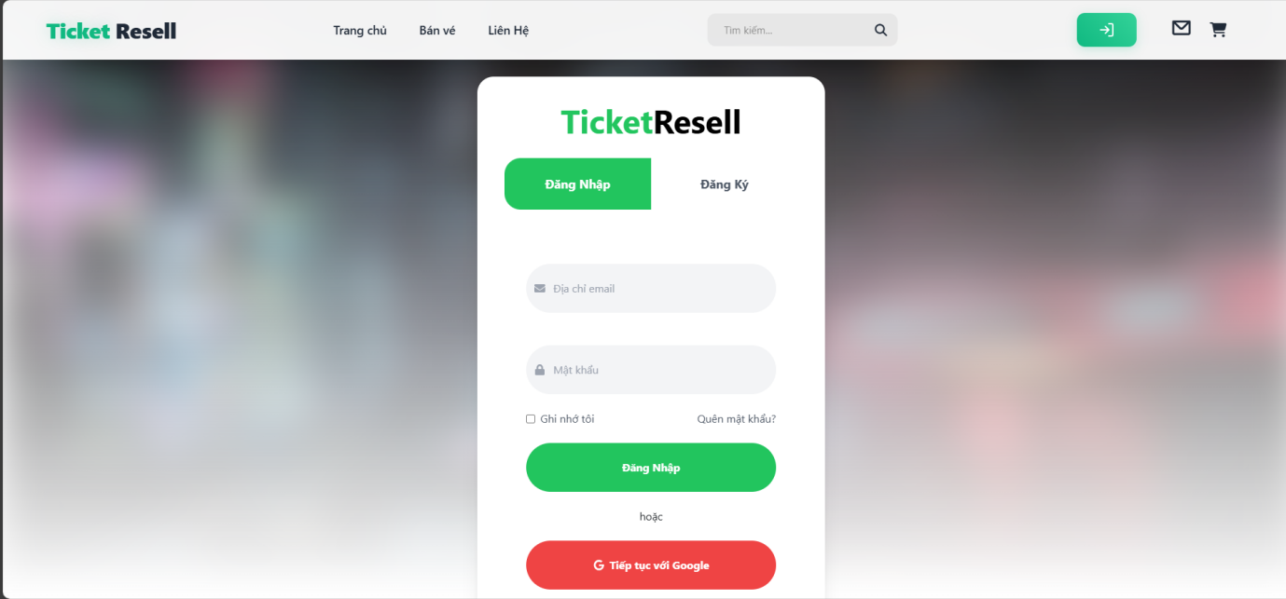

#### 5.2.2/ Signup Page

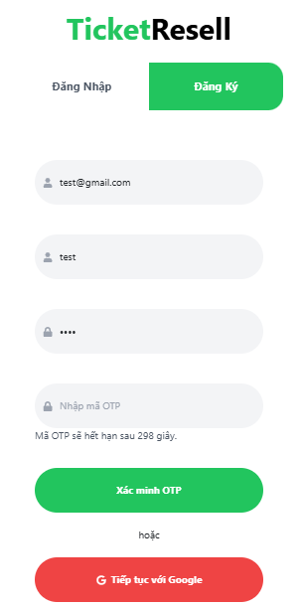

#### 

#### 5.2.3/ HomePage

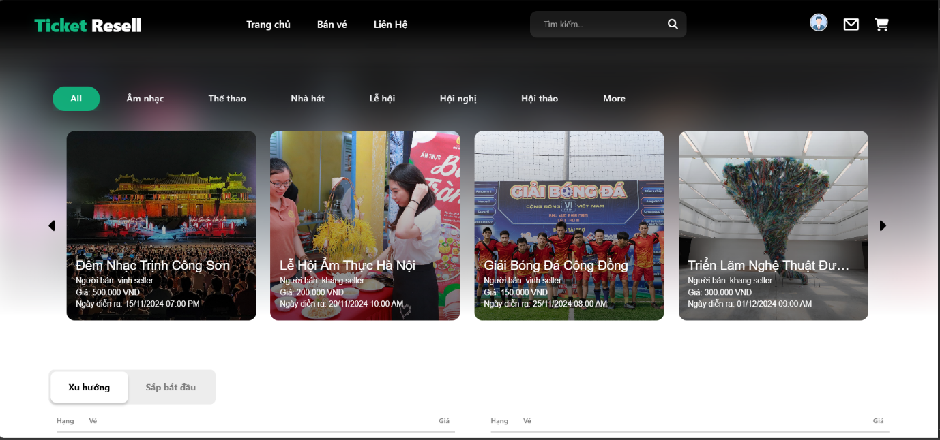

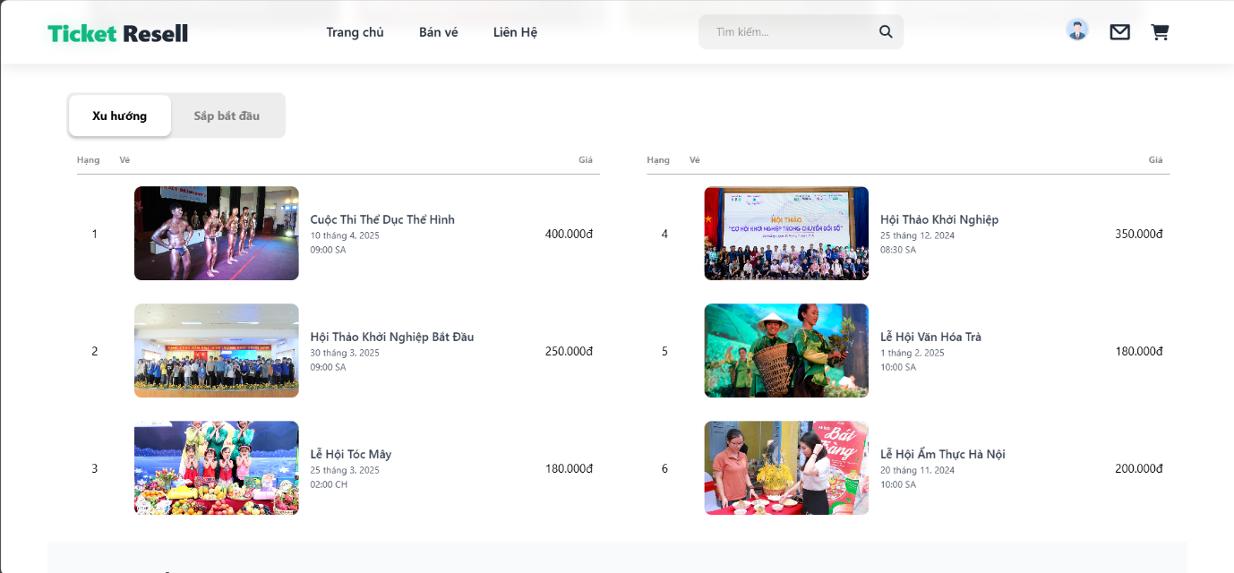

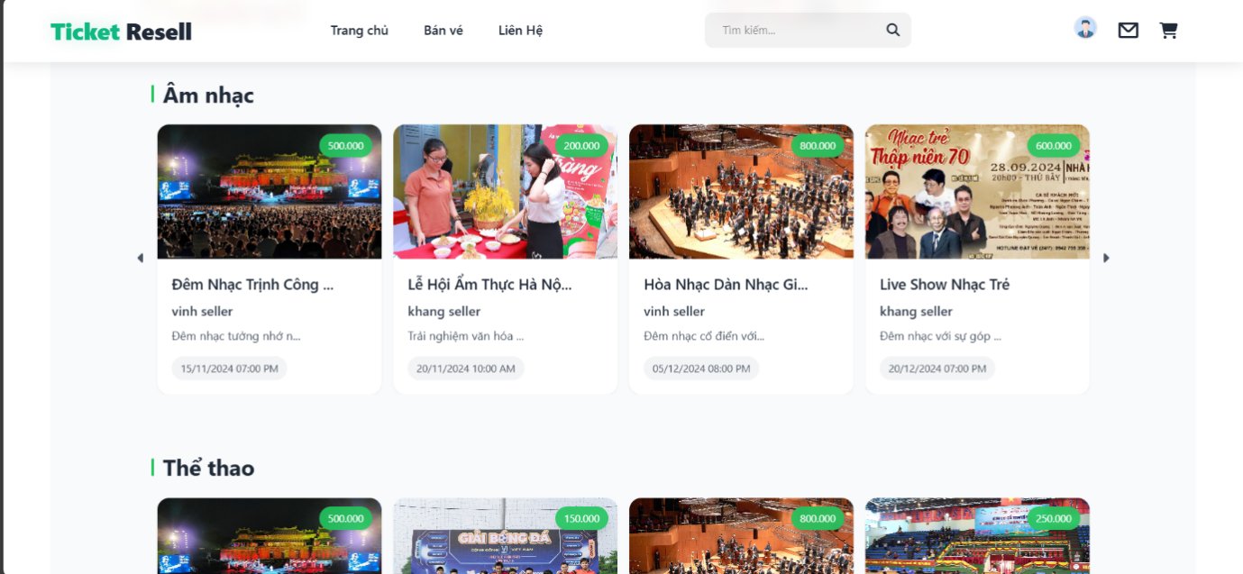

#### 5.2.4/ TicketDetail

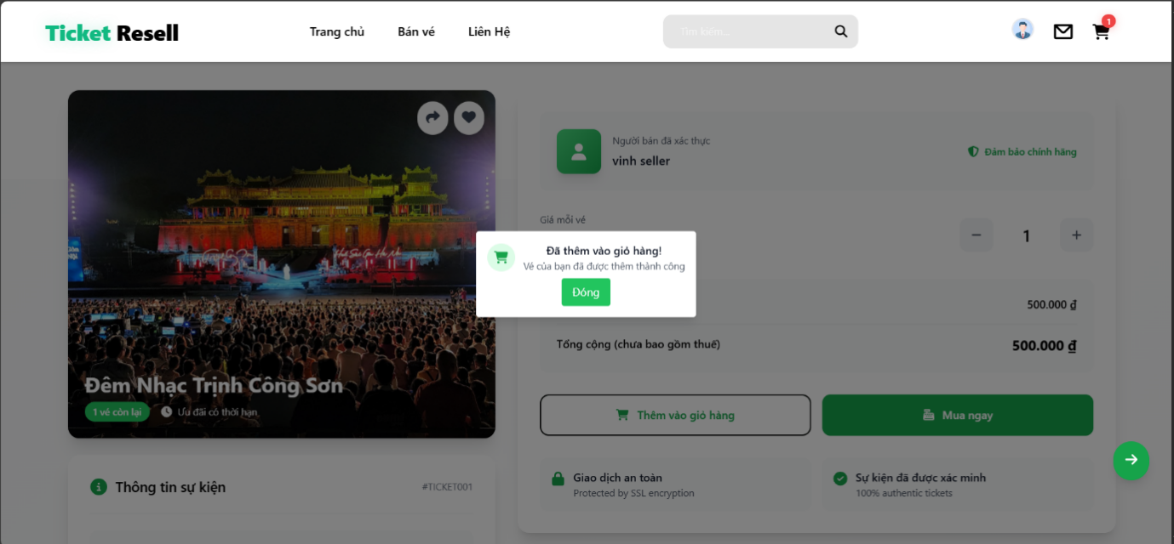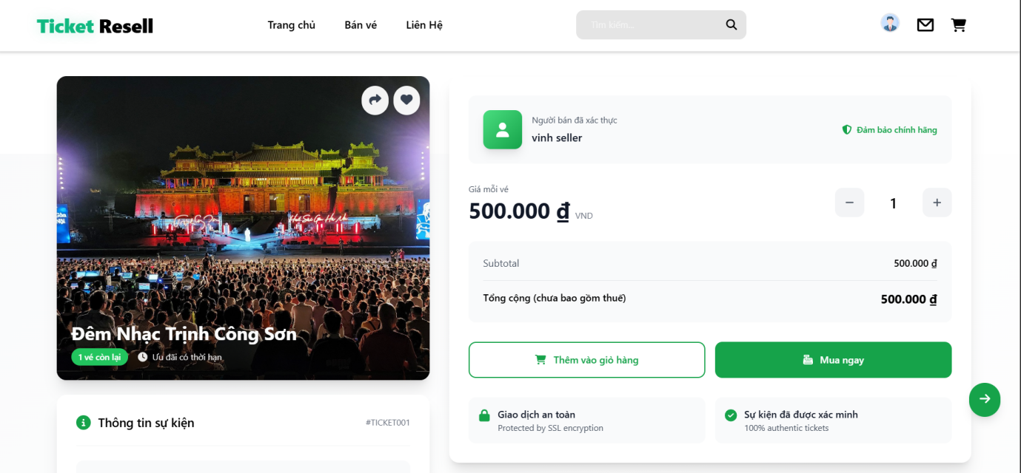

#### 5.2.4/ Browse Tickets

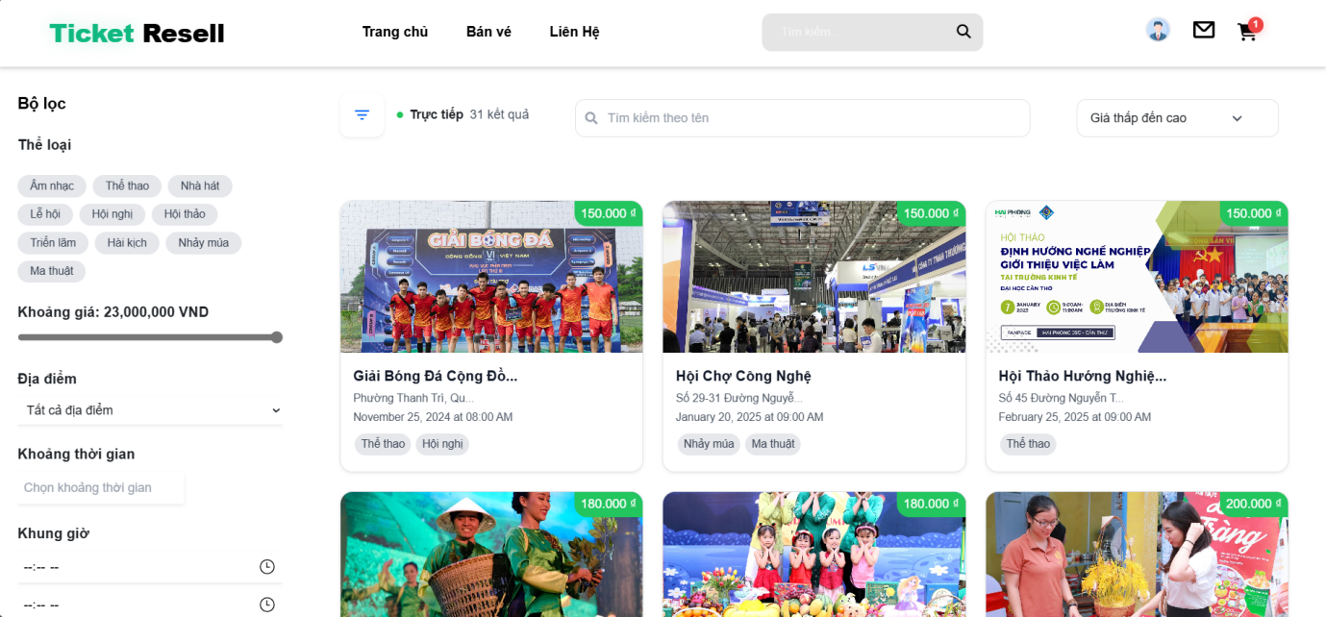

#### 5.3.1/ MyCart

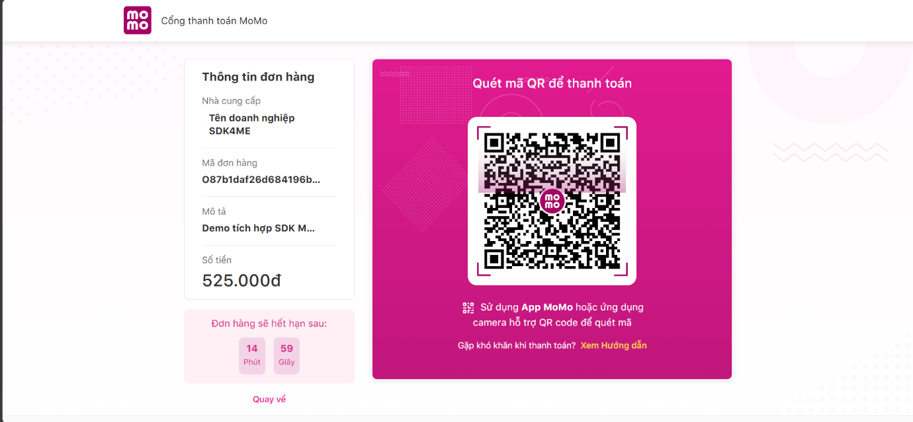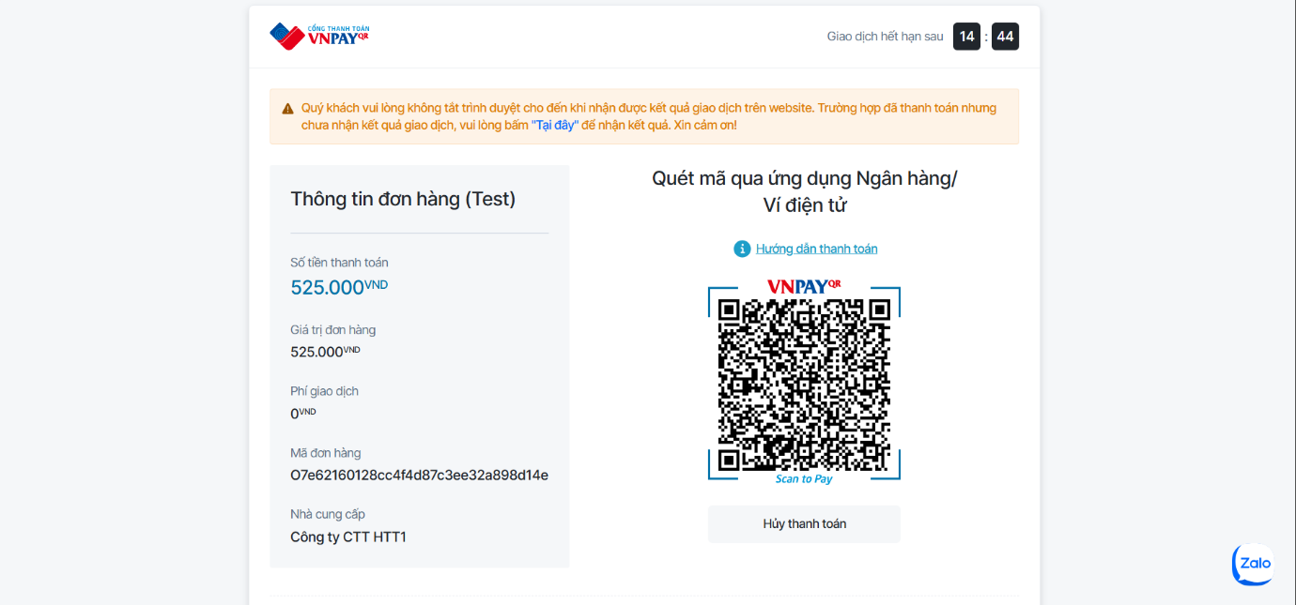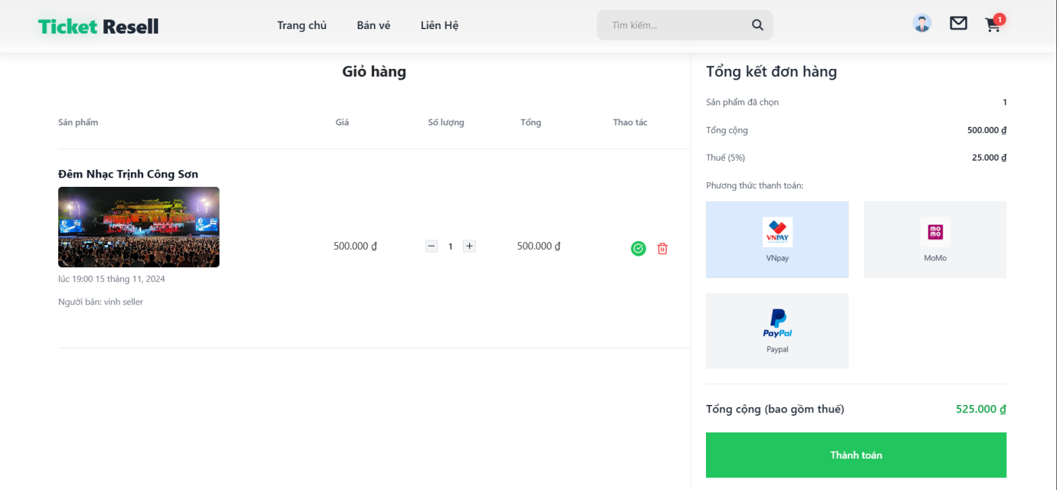

#### 5.3.2/ MyTicket

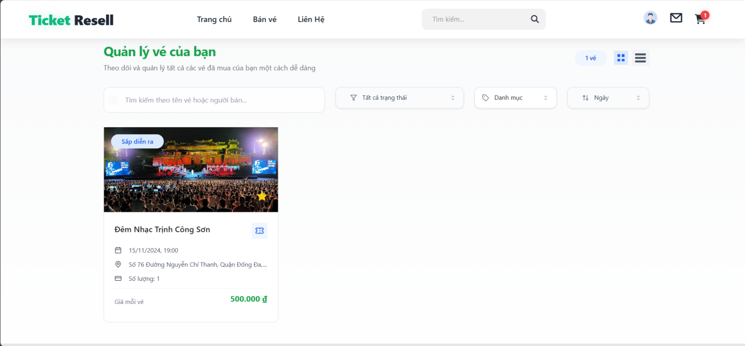

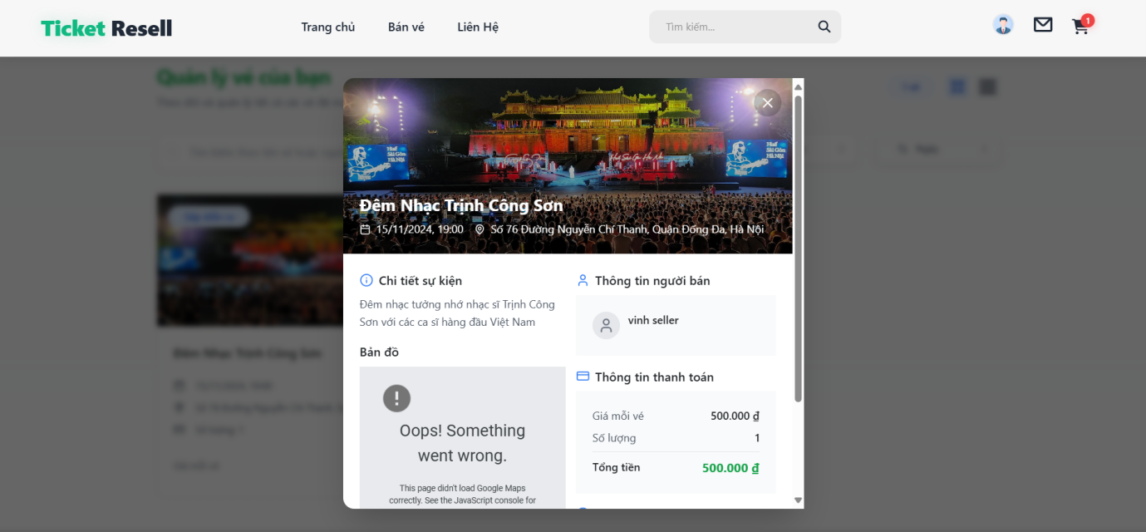

#### 5.3.3/ OrderHistory

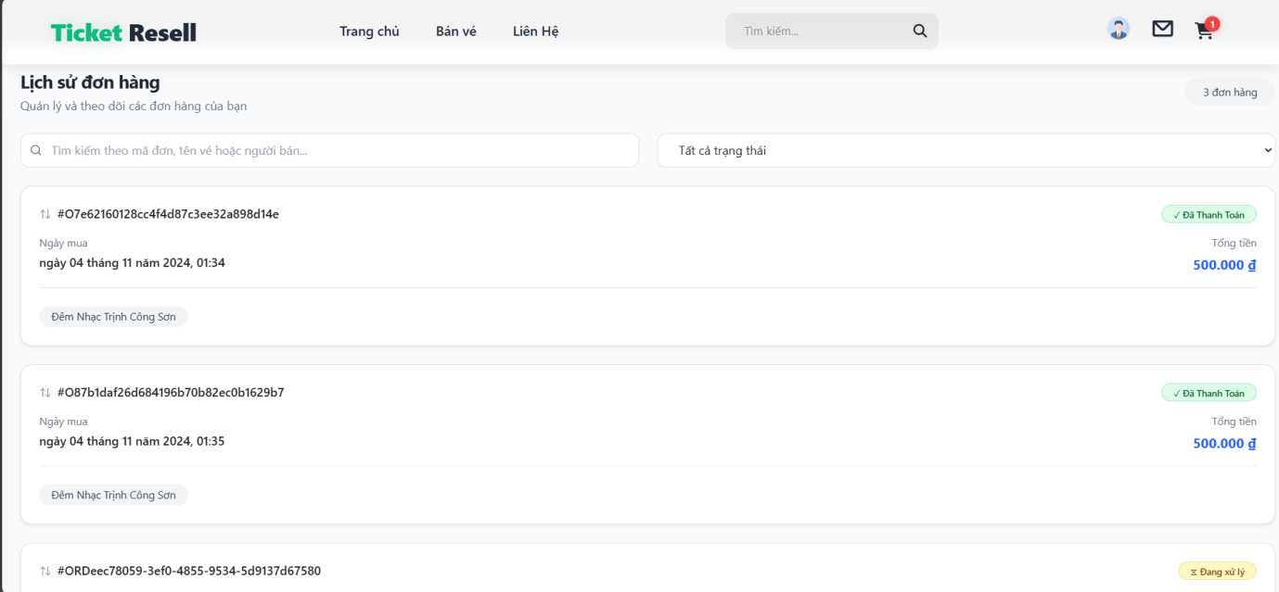

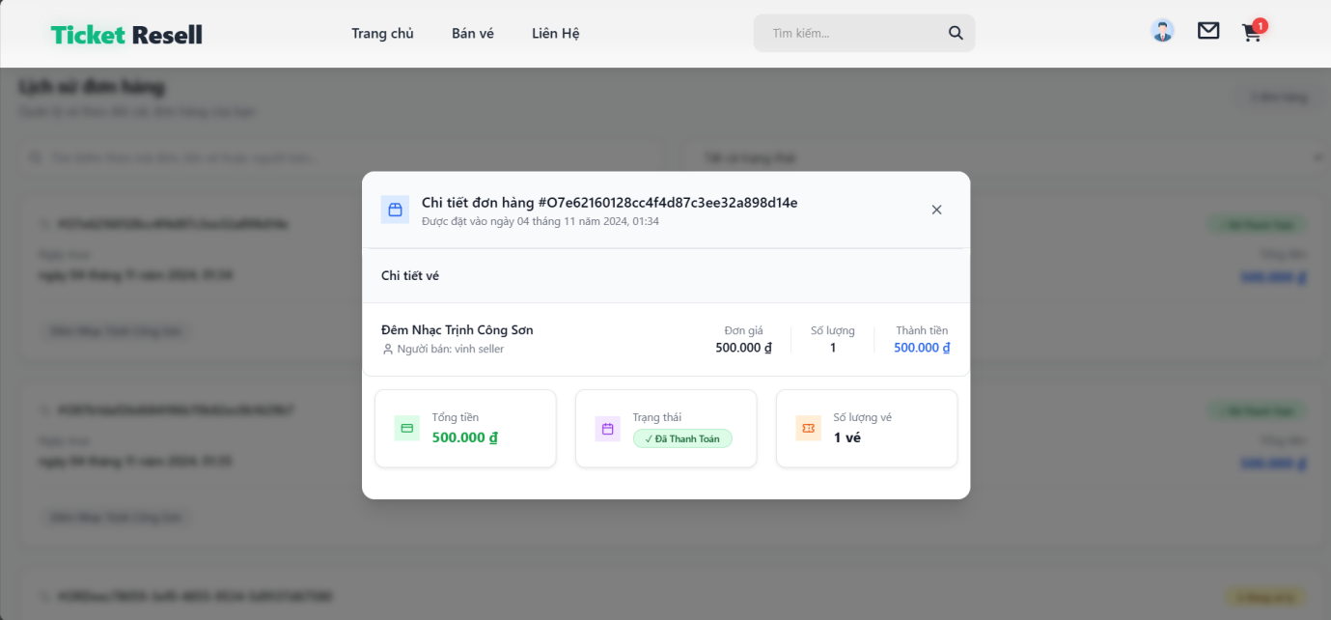

#### 5.3.4/ BuyerProfile

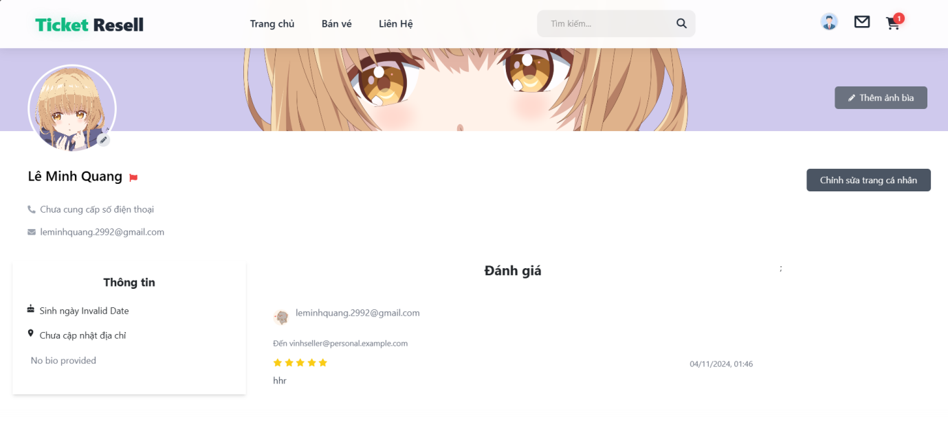

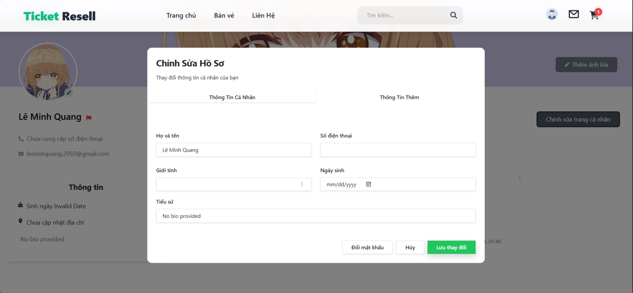

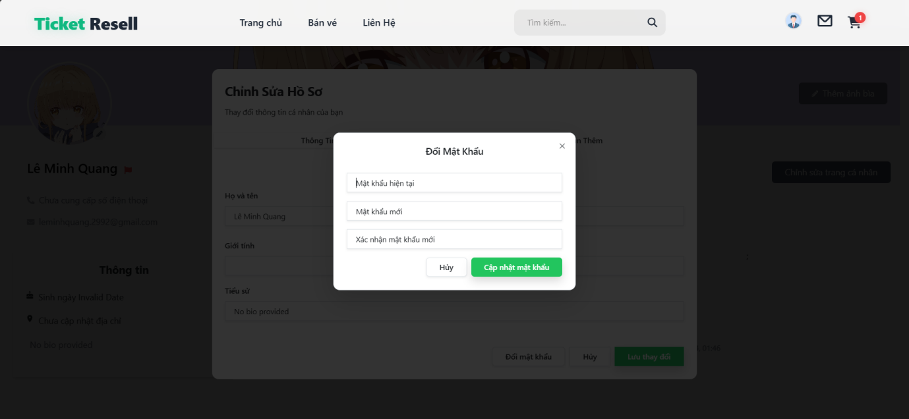

#### 5.3.5/ ReportSeller

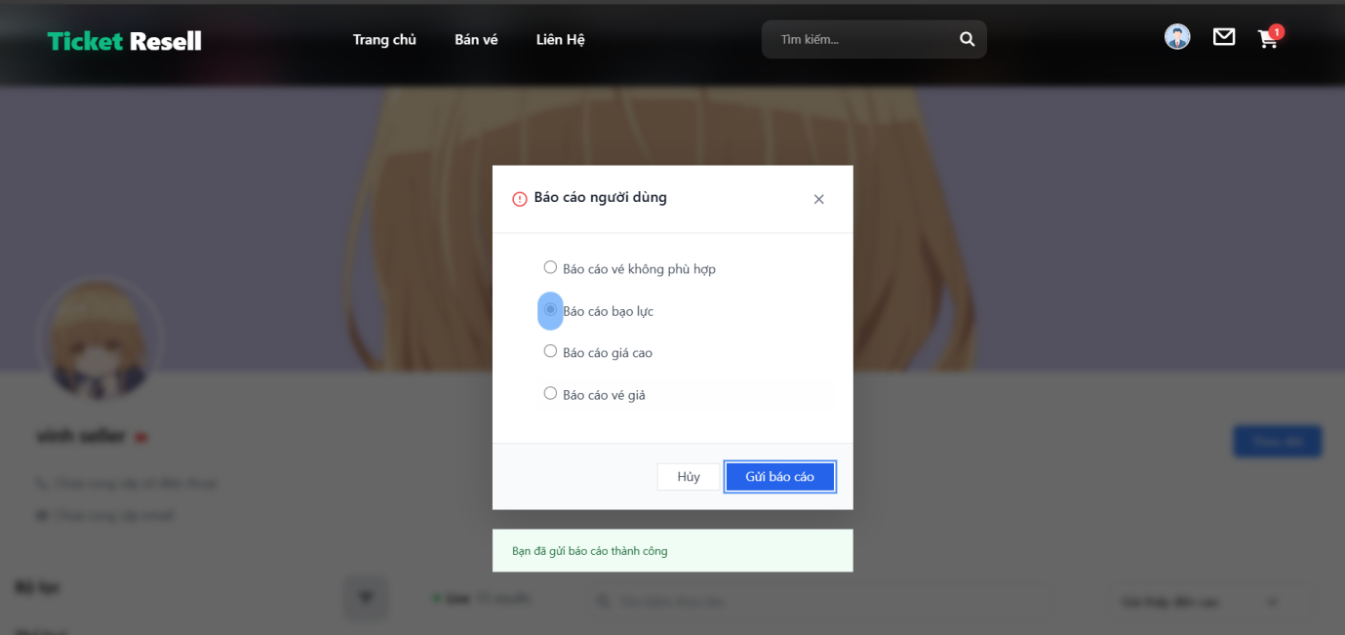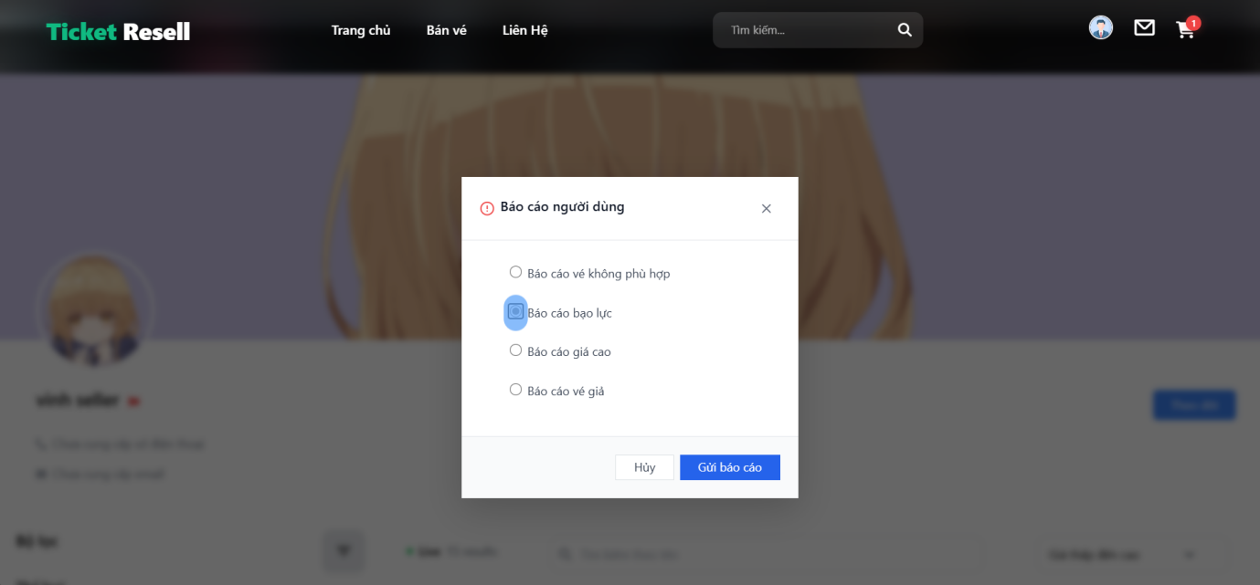

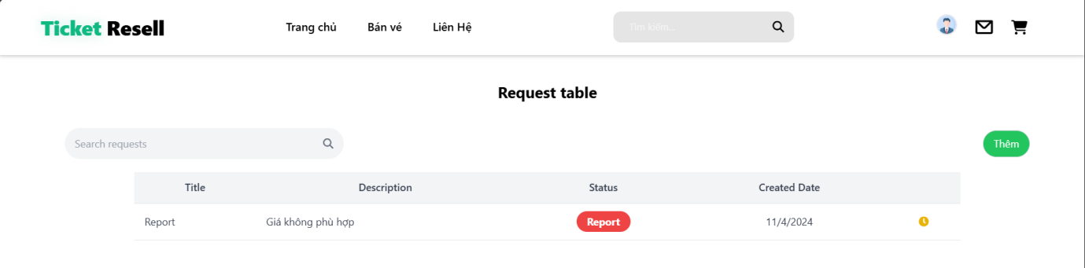

#### 5.4.1/ Signup Seller

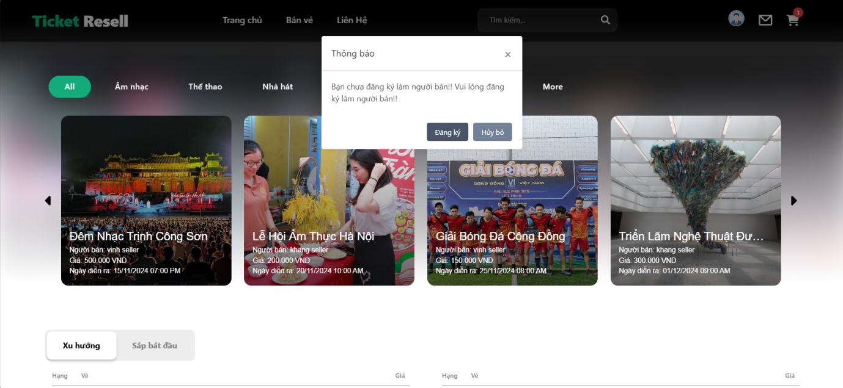

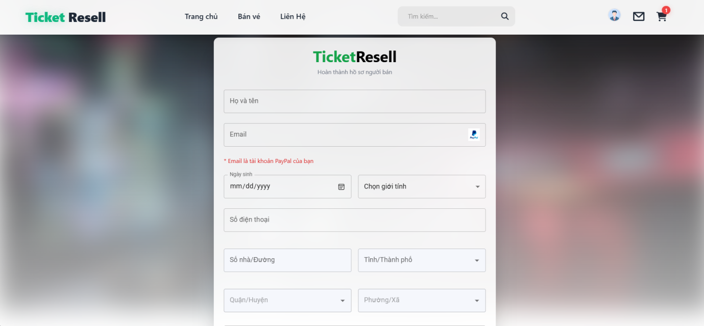

#### 5.4.2/ Seller’s Pages

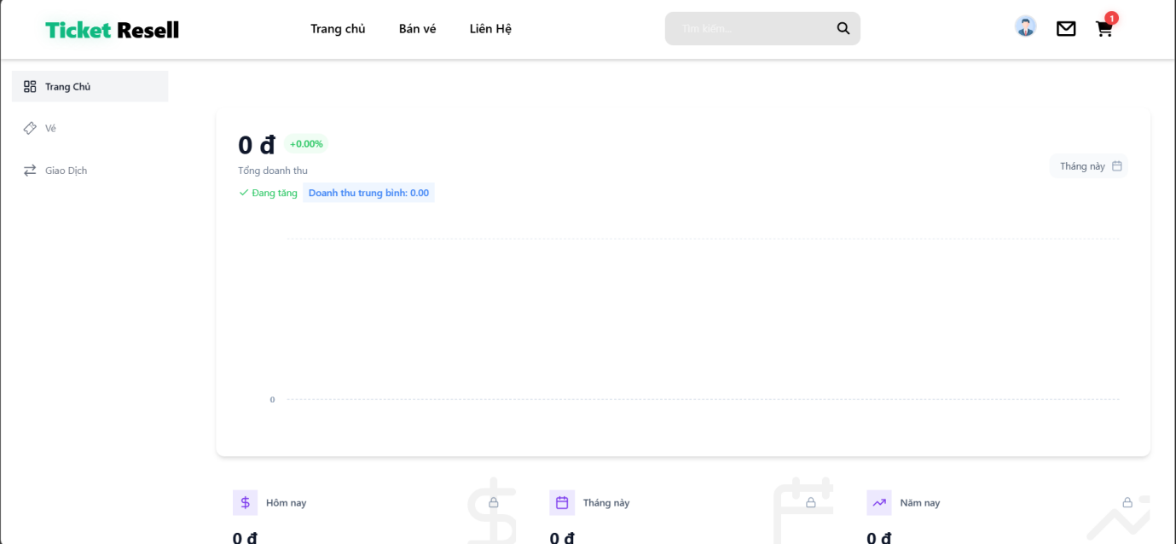

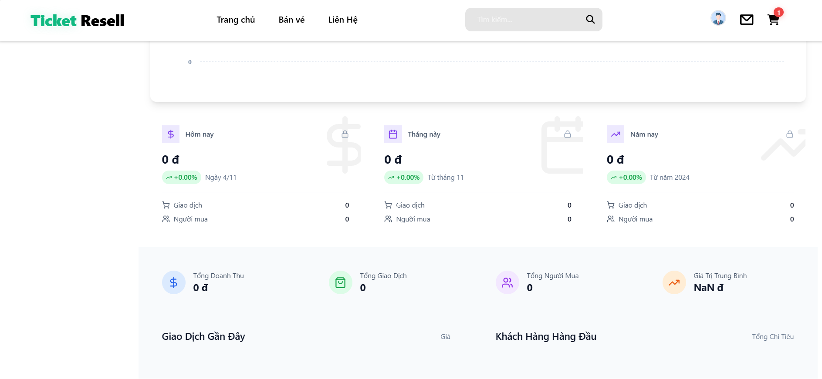

#### 

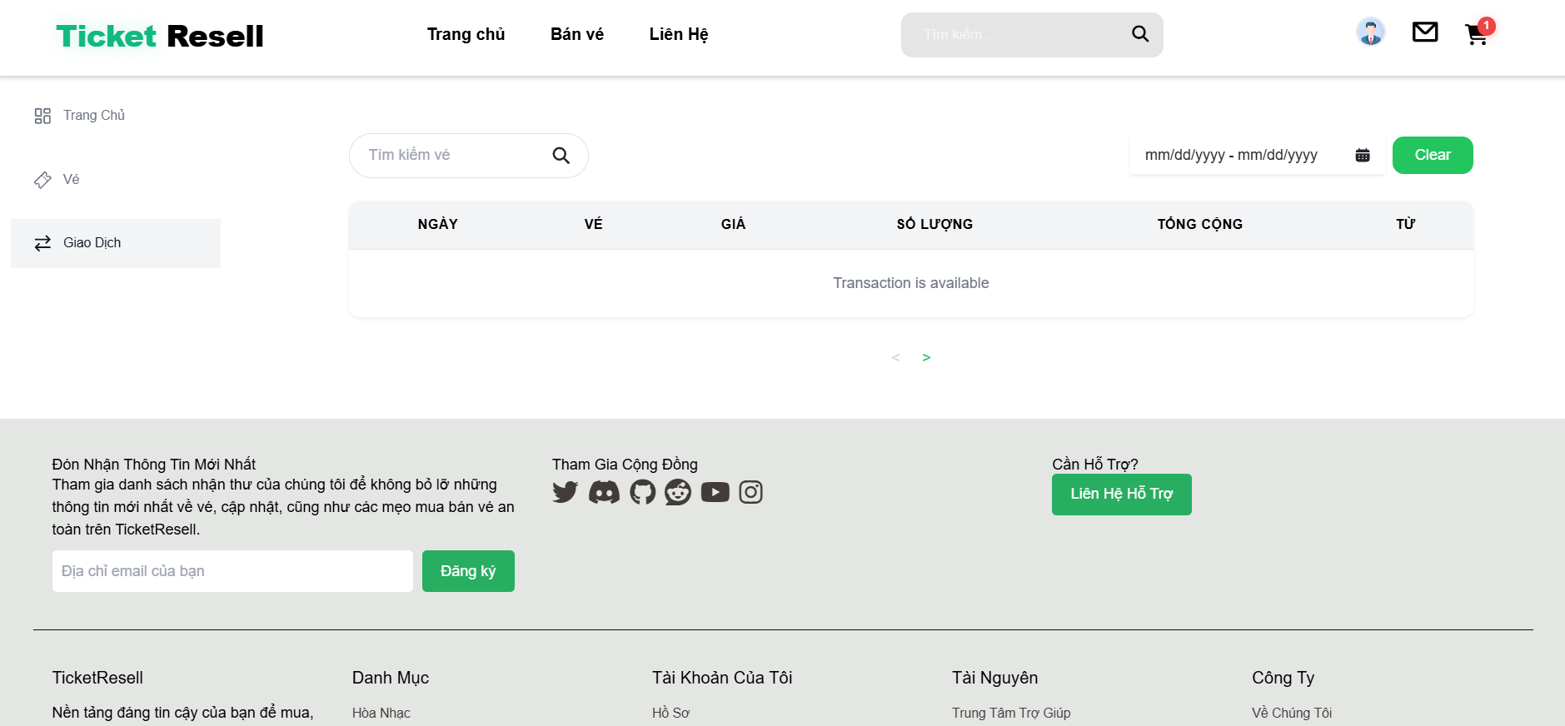

#### 5.4.3/ Sell Ticket

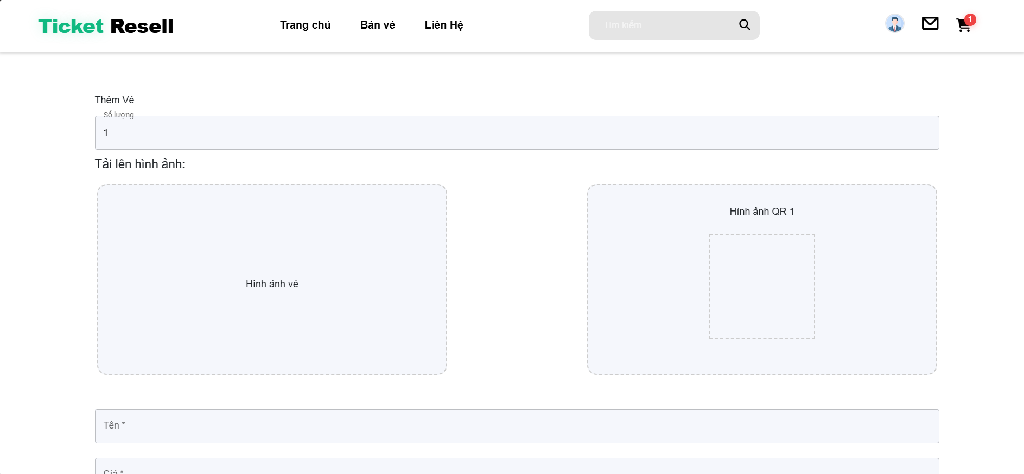

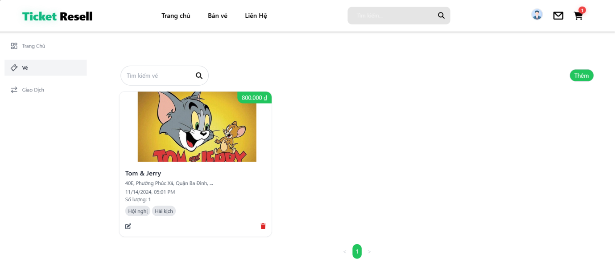

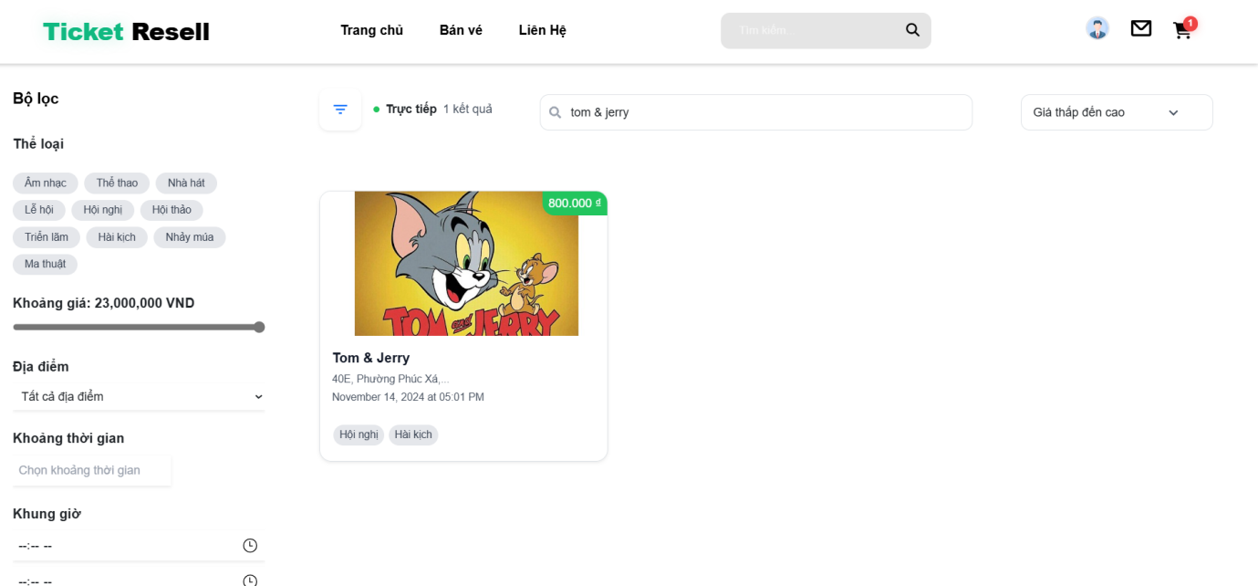

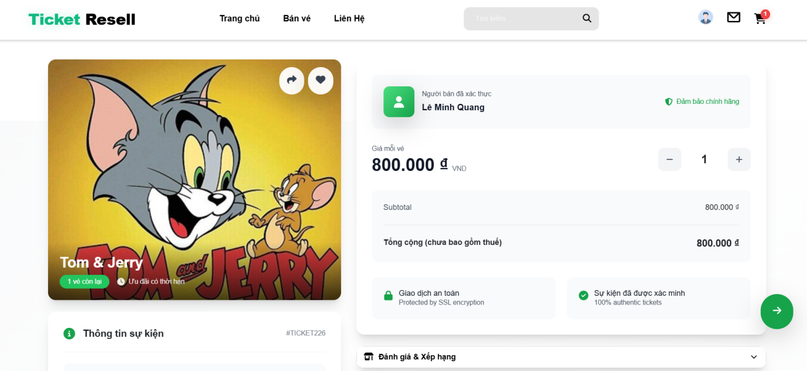

#### 5.5.1/ StaffDashboard

#### 

#### 

#### 5.5.2/ SupportUser

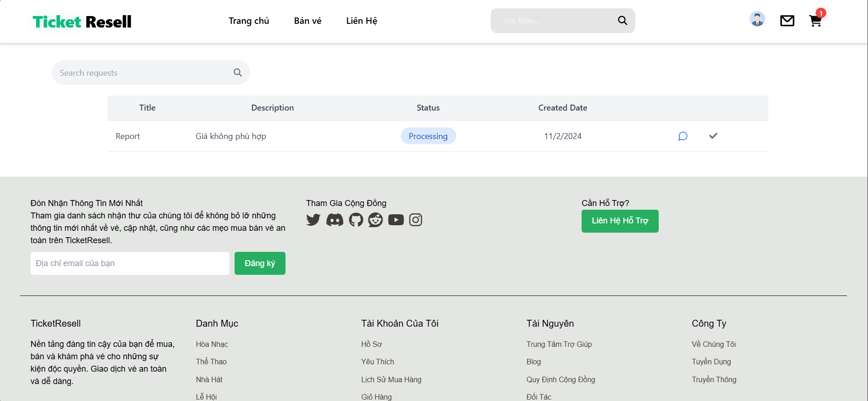

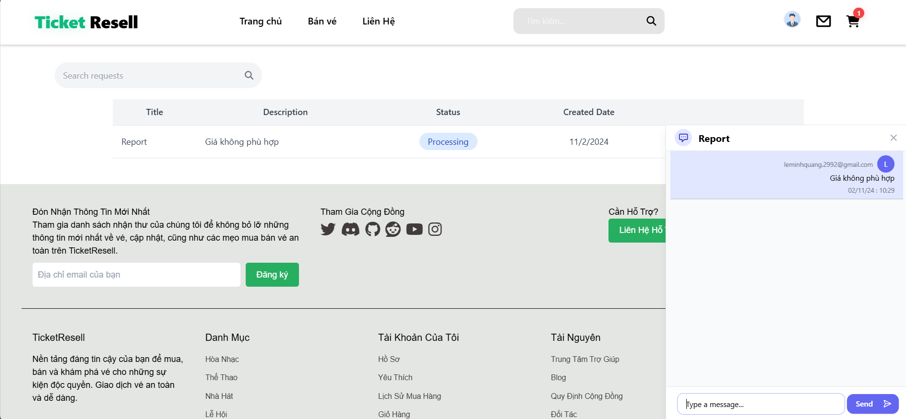

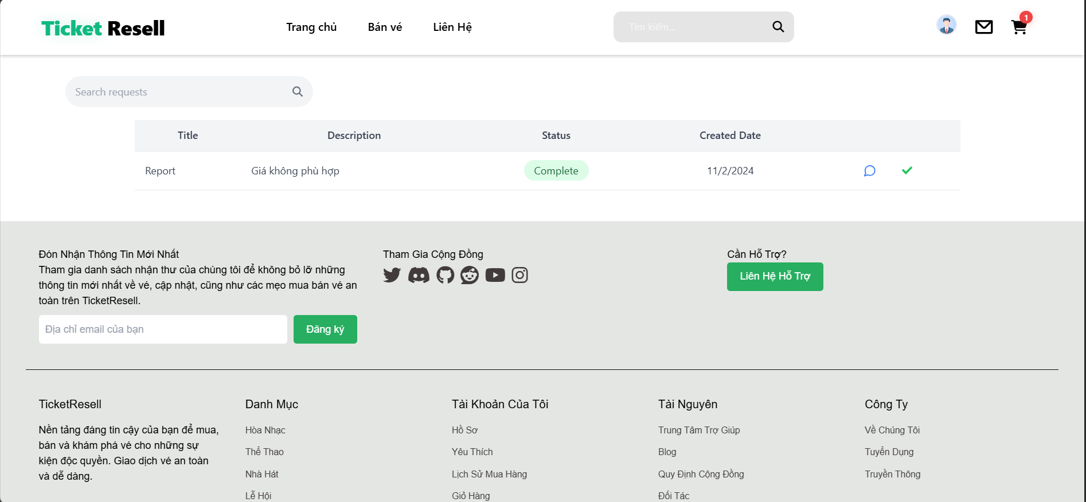

#### 5.6.1/ Admin - UserManagement

#### 5.6.2/ Admin – RoleManagement

#### 

#### 5.6.3/ Admin – TicketManagement

#### 5.6.4/ Admin – CategoryManagement

#### 5.6.5/ Admin – OrderManagement

#### 5.6.6/ Admin – RevenueManagement

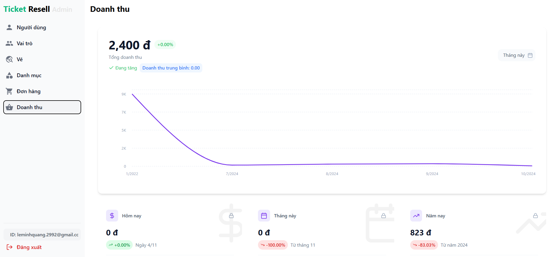

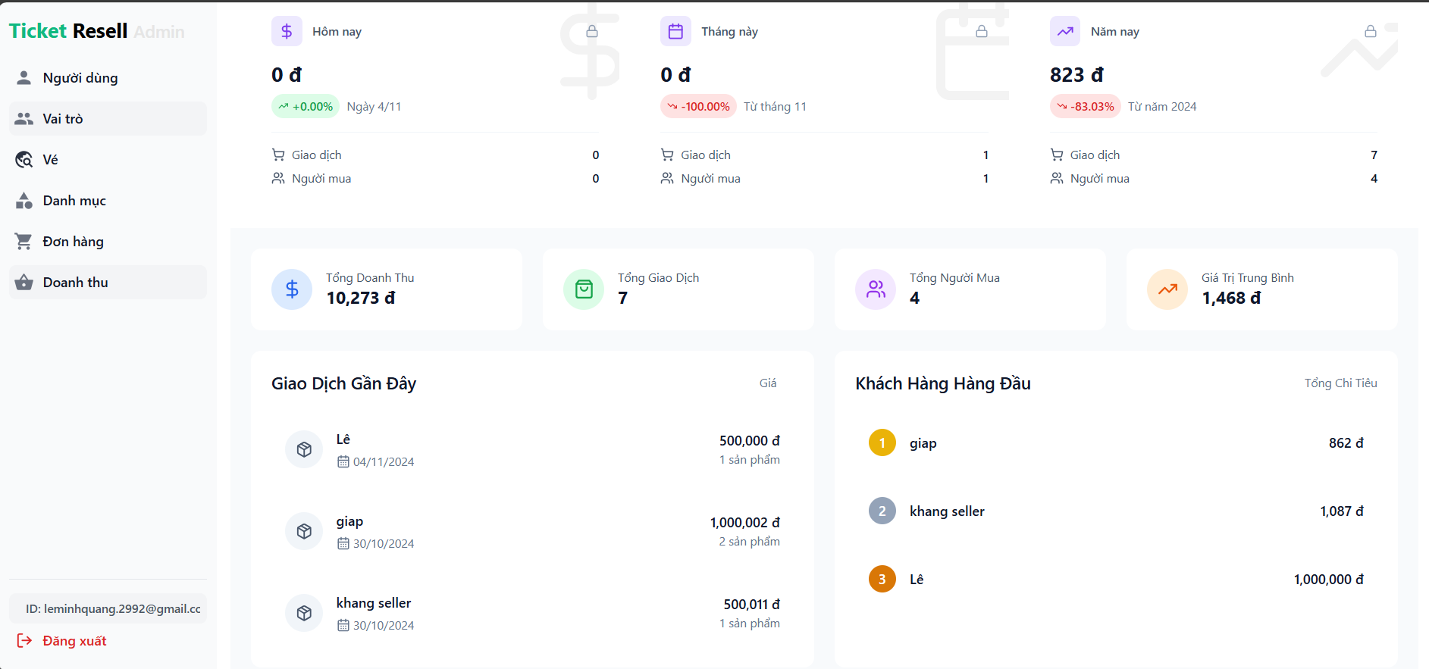

## 6/ Screen Flow

### 6.1/ Admin Screenflow

### Admin flow.drawio

## 7/ Non-Functional Requirement

### 7.1 External Interfaces

#### *7.1.1 User Interfaces*

* The system should provide a responsive web interface that is accessible on various devices, including desktops, tablets, and smartphones.
* The UI should be intuitive and easy to navigate, allowing users to perform tasks such as ticket purchasing, selling, and account management with minimal effort.

#### 7.1.2 Payment Gateway Interface

* The system should integrate with multiple payment gateways (e.g., PayPal, VNPay) to process transactions securely.
* Payment interfaces should support various payment methods, including credit/debit cards and digital wallets.

#### 7.1.3 API Interfaces

* The system should expose RESTful APIs for integration with third-party services, such as payment gateways and email services.
* APIs should be documented using tools like Swagger to facilitate easy integration and usage by external developers.

#### 7.1.4 Database Interface

* The system should interact with a relational database (e.g., SQL Server) to store and retrieve data efficiently.
* Database access should be abstracted through a repository pattern to ensure separation of concerns and ease of maintenance

#### 7.1.5 Email Service Interface.

- The system should integrate with an email service to send notifications, OTPs, and other communications to users.

-Email templates should be customizable to support different languages and branding requirements.

### 7.2 Quality Attributes

#### 7.2.1 Scalability

* The system should be designed to scale horizontally to accommodate increasing user loads and data volumes.
* Cloud-based infrastructure should be considered to support dynamic scaling and resource allocation.

#### 7.2.2 Reliability

#### - The system should ensure high availability and minimal downtime, with failover mechanisms in place to handle hardware or software failures.

- Regular backups and disaster recovery plans should be implemented to prevent data loss.

#### 7.2.3 Performance

- The system should handle a high volume of concurrent users without significant degradation in response time.

-Critical operations, such as ticket purchasing and payment processing, should complete within a few seconds.

#### 7.2.4 Maintainability

- The system should be modular and well-documented to facilitate easy maintenance and updates.

- Code should adhere to best practices and coding standards to ensure readability and consistency.

#### 7.2.5 Security

- The system should implement robust security measures, including data encryption, secure authentication, and authorization mechanisms.

- Sensitive data, such as user credentials and payment information, should be protected using industry-standard practices.

#### 7.2.5 Usability

- The system should provide a user-friendly interface with clear instructions and feedback to guide users through various processes.

* Accessibility features should be included to support users with disabilities.

## 8. Business Rules

### BR-1: User Registration and Authentication

* Users must register with a valid email address and create a secure password to access the platform.
* Users must verify their email address through a confirmation link sent to their registered email before they can perform any transactions.

### BR-2: Ticket Listing and Selling:

* Only registered and verified users can list tickets for sale on the platform.
* Sellers must provide accurate and complete information about the tickets, including event details, seat numbers, and pricing.
* Sellers can set their own prices, but the platform may impose a minimum or maximum price limit to ensure fair market practices.

### BR-3: Ticket Purchasing

* Buyers must have a registered account to purchase tickets.
* Payment must be completed through the platform's integrated payment gateways before a ticket purchase is confirmed.
* Once a purchase is made, the transaction is final, and refunds are subject to the platform's refund policy.

### BR-4: Payment Processing

* All transactions must be processed through secure payment gateways integrated with the platform.
* The platform may charge a service fee or commission on each transaction, which will be deducted from the seller's proceeds.

### BR-5: Refunds and Cancellations

* Refunds are only available under specific conditions, such as event cancellation or significant changes to event details.
* Users must request refunds within a specified time frame, and all refund requests are subject to approval by the platform.

### BR6-: User Conduct and Content

* Users must adhere to the platform's code of conduct, which prohibits fraudulent activities, abusive behavior, and the sale of counterfeit tickets.
* The platform reserves the right to suspend or terminate accounts that violate the terms of service or engage in prohibited activities.

### BR-7: Dispute Resolution

* The platform provides a mechanism for resolving disputes between buyers and sellers, such as issues with ticket authenticity or delivery.
* Users are encouraged to resolve disputes amicably, but the platform may intervene if necessary..

### BR-8: Data Privacy and Security

* The platform must comply with data protection regulations, ensuring that user data is collected, stored, and processed securely.
* Users have the right to access, modify, or delete their personal information as per the platform's privacy policy.

### BR-9: Event Listing and Management

* Event organizers can list events on the platform, providing detailed information such as date, time, venue, and ticket availability.
* Organizers must ensure that all event details are accurate and up-to-date, and they are responsible for notifying the platform of any changes.

### BR-10: Ticket Transfer and Resale

* Users can transfer purchased tickets to other registered users through the platform's secure transfer system.
* Resale of tickets is allowed, but the platform may impose restrictions on the number of times a ticket can be resold.

### BR-11: Loyalty and Rewards Program

* The platform may offer a loyalty program where users earn points for transactions, which can be redeemed for discounts or special offers.
* Points are non-transferable and may expire after a certain period if not used.

### BR-12: Promotions and Discounts

* The platform can offer promotional discounts or codes to users, subject to terms and conditions.
* Discounts cannot be combined with other offers unless explicitly stated.

### BR-13: Account Management

* Users are responsible for maintaining the confidentiality of their account credentials and for all activities that occur under their account.
* Users must promptly notify the platform of any unauthorized use of their account or security breaches.

### BR-14: Feedback and Reviews

* Buyers can leave feedback and reviews for sellers after completing a transaction, which will be visible to other users.
* The platform reserves the right to remove reviews that violate community guidelines or contain inappropriate content.

### BR-15: Compliance and Legal Obligations

* The platform must comply with all applicable laws and regulations, including those related to ticket sales, consumer protection, and taxation.
* Users are responsible for ensuring that their activities on the platform comply with local laws and regulations.

### BR-16: Platform Maintenance and Updates

* The platform may undergo scheduled maintenance or updates, during which some features may be temporarily unavailable.
* Users will be notified in advance of any planned downtime or significant changes to the platform.

### BR-17: Customer Support

* The platform provides customer support to assist users with inquiries, issues, or disputes.
* Support is available through various channels, such as email, chat, or phone, during specified hours.